- Download release version MagentoV2
https://github.com/indodana/paylater-ecommerce-plugin-php/releases

- Extract
- Copy plugin/app/ to <magento root>/app/
- Set folder Acces Permission
cd <magento_root>
find var generated vendor pub/static pub/media app/etc -type f -exec chmod u+w {} +
find var generated vendor pub/static pub/media app/etc -type d -exec chmod u+w {} +
chmod u+x bin/magento
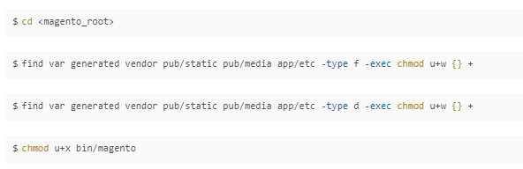

- Pastikan apache/ngix punya hak write
- Run <magento_root>$sudo bin/magento setup:upgrade
- Run <magento_root>$sudo bin/magento module:enable Indodana_PayLater
- Run <magento_root>$sudo bin/magento setup:upgrade

- Jika mode developer skip bagian ini ( coba skip dulu )
Run <magento_root>$sudo bin/magento setup:di:compile
- Run <magento_root>$sudo bin/magento setup:static-content:deploy –f
- Pastikan apache/ngix punya hak write
Atau mudahnya jalankan
sudo chown -R ubuntu:www-data <magento_root>
contoh
sudo chown -R ubuntu:www-data /var/www/magento/
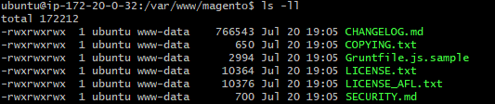

- Tes magento web

